**Telecom Customer Churn Prediction**



**Objective:**

The primary goal of this project is to **predict customer churn** in order to develop effective customer retention strategies. By analysing various **customer attributes** and **demographic information**, we aim to identify patterns that indicate a higher likelihood of **churn**. Through this analysis, we seek to provide insights that can guide the development of targeted retention programs to reduce customer attrition.

**Exploratory Data Analysis (EDA):**

* During the EDA phase, we delved into the dataset to gain a comprehensive understanding of the variables and their relationships.
* We examined the distribution of customer churn, explored correlations between different features, and visualized demographic characteristics of the customer base.
* Furthermore, we conducted univariate and bivariate analyses to identify potential predictors of churn and to uncover any significant trends or patterns in the data.

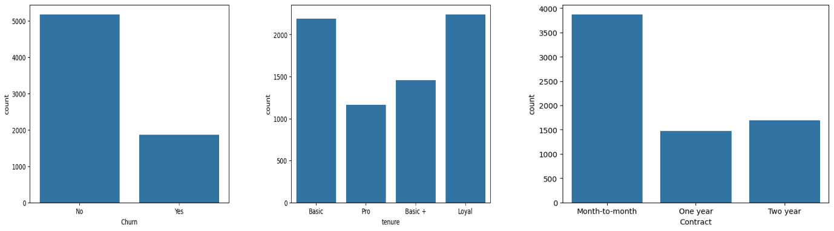

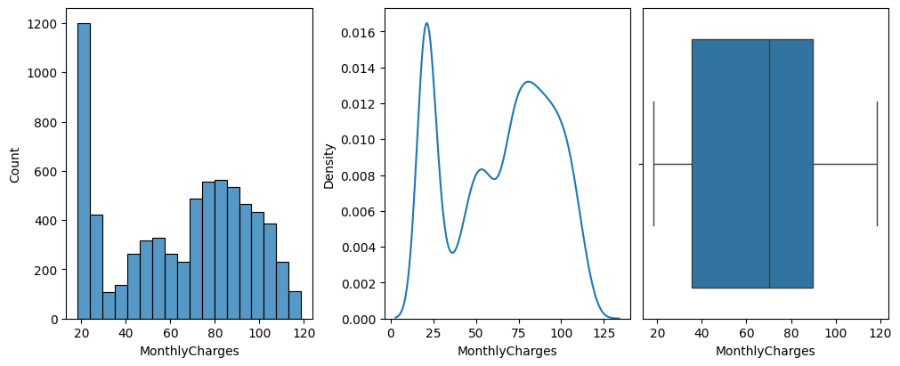

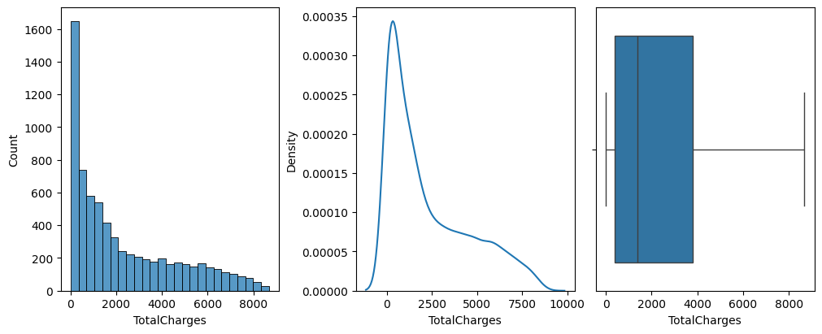

**Model Building:**

* In the model building stage, we constructed predictive models using various machine learning algorithms, including K-Nearest Neighbours (**KNN**), **Logistic Regression, Random Forest**, and **Decision Trees.**
* We trained these models on the dataset, utilizing techniques such as **Grid Search cross-validation** to ensure robust performance.
* Our objective was to **evaluate** the efficacy of each model in predicting customer churn accurately.

**Model Performance Comparison:**

Among the models built, **Random Forest** exhibited the **highest performance** in terms of predictive accuracy.

We **evaluated** the models based on **metrics** such as **accuracy** with **Random Forest** consistently **outperforming** the other models across the metrics.

This indicates that **Random Forest** is the most suitable algorithm for **predicting customer churn** in this context.

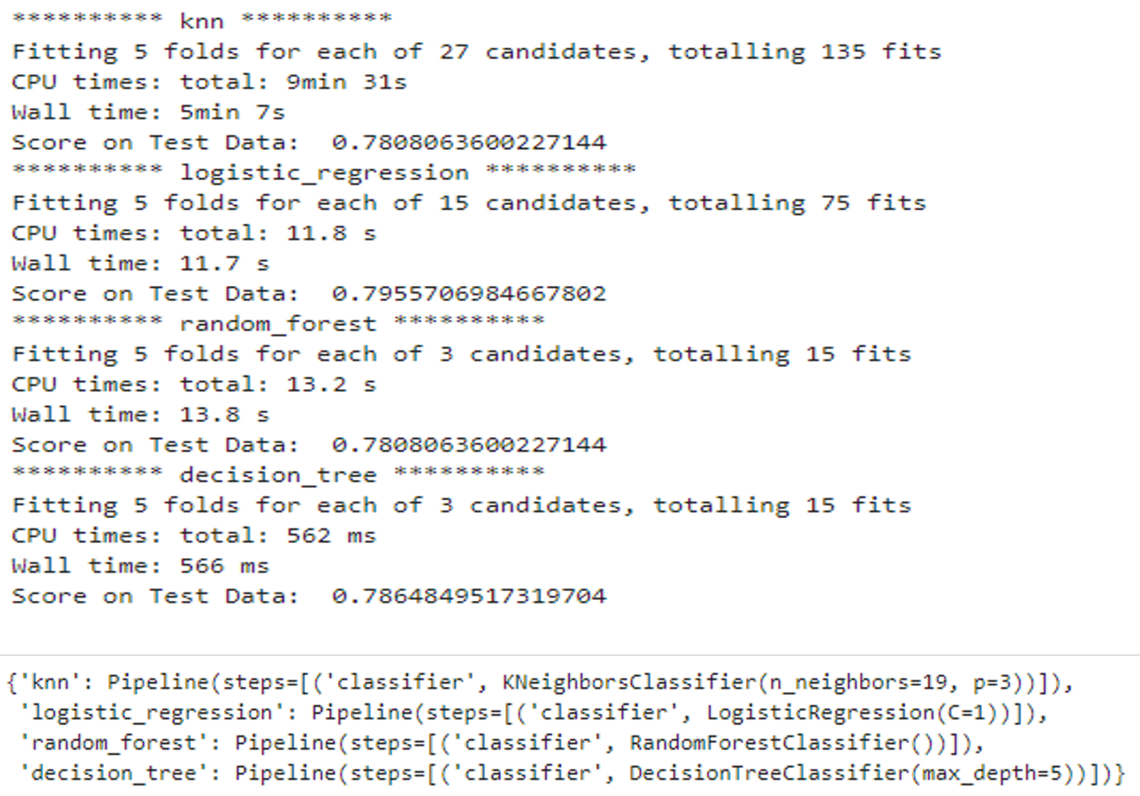

**Recommendations and Next Steps:**

* Given the superior performance of **Random Forest**, we recommend deploying this model in production to predict customer churn effectively.
* Additionally, we suggest further refining the model by fine-tuning hyperparameters even more and exploring feature engineering techniques to potentially enhance its performance further.
* Moreover, ongoing monitoring and validation of the model's predictions against real-world churn data will be crucial to ensure its continued effectiveness in driving customer retention efforts.